

SIMATS ENGINEERING

Saveetha Institute of Medical and Technical Sciences Chennai- 602105

Student Name: Maniyar Mohammad Rehan Reg. No.:192425391
Course Code: MLA0408 Slot: C
Course Name: DEEP LEARNING
Course Faculty: Dr D Sudhagar

Project Title: Deep Learning-Based Smart Real-Time Emergency Resource Allocation and Inventory Monitoring System
MODULE : Emergency Request & Resource Demand

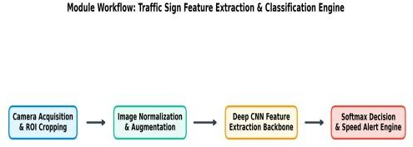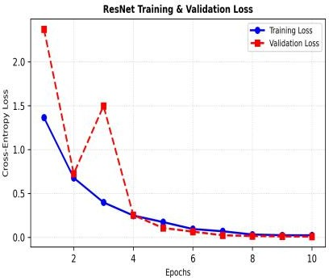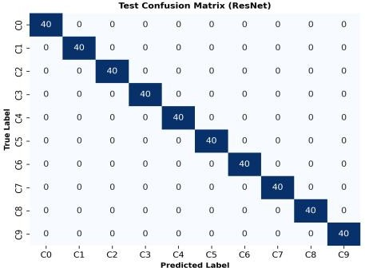

Project Description:
- Collected real-time emergency requests and identified the resources required for each situation.
- Classified emergency requests based on urgency, type, location, and resource requirements.
- Analyzed request patterns to understand resource demand during different emergencies.
- Used deep learning techniques to predict the type and quantity of resources needed.
- Developed a prioritization approach to identify critical requests and support faster response Key Components
My contribution focuses on the Emergency Request & Resource Demand module of the system.
I worked on organizing real-time emergency requests, identifying the required resources, analyzing demand patterns, and supporting demand prediction using deep learning techniques. The module is designed to prioritize critical emergencies and provide reliable resource-demand information to the allocation module, helping the overall system achieve faster and more efficient emergency response.

